
Company
Logotype

Cone Beam Computed Tomography- Report



Porur Dental X-rays & CBCT

Patient Name : Mr. Sai Harshavardhan | Date of Report : 07.04.2024
Age/ Gender : 14 years/ Male | Region of Interest : CBCT Sectional Mandible
Referring doctor: Dr. Sujatha | Indication : Cyst in relation to right side of mandible
Clinical Notes: Nil
PATIENT INFORMATION

CBCT Sectional Mandible provided
CBCT – IMAGE DETAILS

RADIOGRAPHIC INTERPRETATION

- In 46, presence of hyperdense restorative material within the crown extending into the pulp canal upto the apical third of the roots.
- In relation to the periapical aspect of 46, 47, presence of a single, expansile, unilocular, hypodense area bounded by a diffuse margin measuring 21.17 x 8.57 x 11.66 mm in dimension.
- The hypodense region appears to be in proximity to the inferior alveolar nerve canal, appears to push the canal inferiorly and appears to cause mild bucco-lingual expansion.
- The lingual cortical bone is present with extreme thinning.

RADIOGRAPHIC IMPRESSION

- Differential Diagnosis (based on the visible radiological features): Root canal treated tooth 46 with Residual periapical pathology in relation to 46, 47 region.


Kindly correlate with clinical and histopathological features

IMAGES FOR REFERENCE

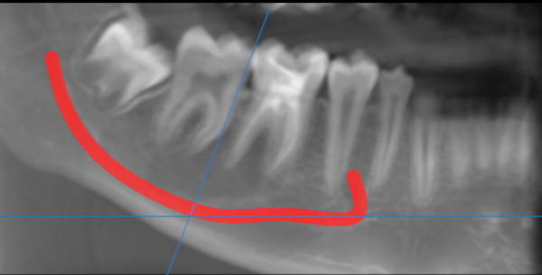
single, expansile, unilocular, hypodense area bounded by a diffuse margin
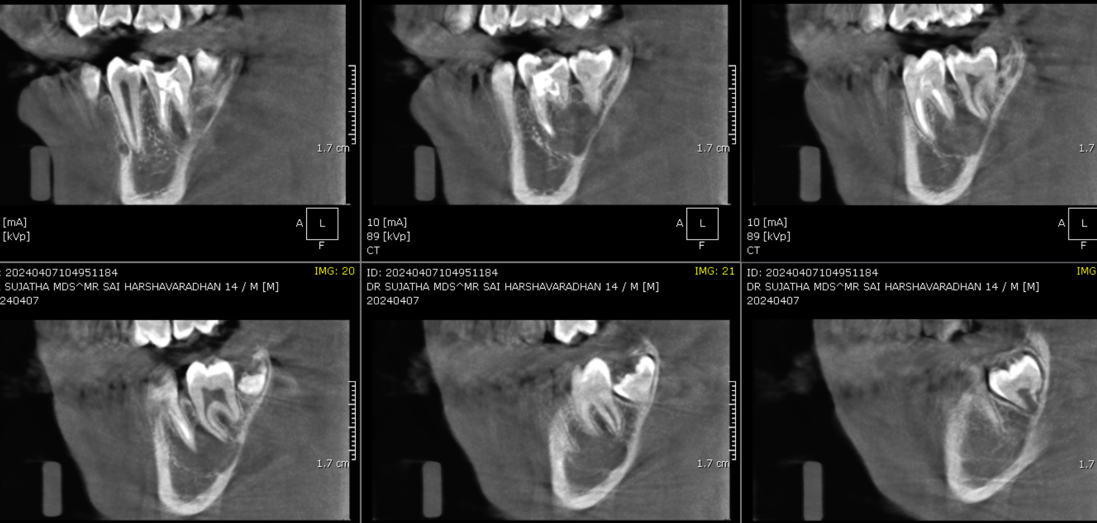
SAGITTAL IMAGES FOR REFERENCE

CROSS SECTIONAL IMAGES FOR REFERENCE
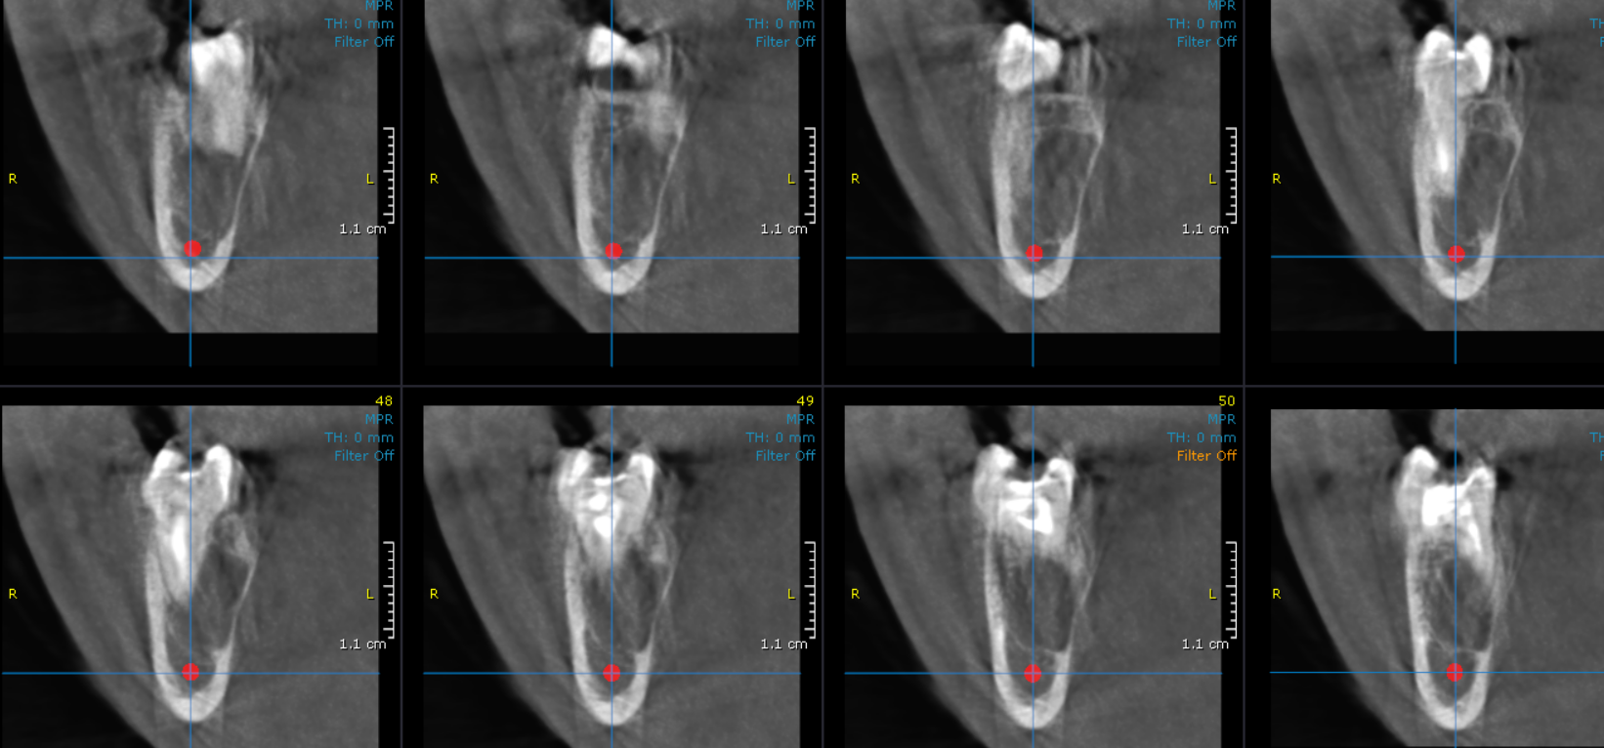

3-DIMENSIONAL VIEW

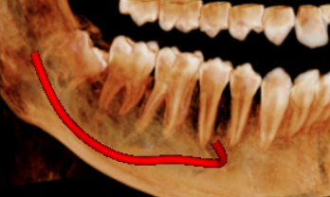

**** End of report ****

